Annex T. Analysis of outliers detected

In the context of a multi-label dataset, an outlier refers to a data point that deviates significantly from the majority of the other data points in terms of its feature values across multiple labels. Since multi-label datasets have multiple target variables (labels), outliers in such datasets can manifest in various ways:

* **Outlier in Feature Space**: An outlier in feature space refers to a data point that has extreme values for one or more features across all labels. These outliers can distort the overall distribution of the data and affect the F performance of machine learning models.
* **Outlier in Label Space**: An outlier in label space refers to a data point that is associated with an unusual combination of labels compared to the rest of the dataset. These outliers may represent rare or anomalous label combinations that occur infrequently in the dataset.
* **Outlier in Feature-Label Space**: An outlier in feature-label space refers to a data point that exhibits extreme values for specific features within the context of certain label combinations. These outliers may have feature values that are unusual or unexpected given their associated label combinations.

Detecting outliers in multi-label datasets involves considering the joint distribution of features and labels. Various statistical techniques, visualization methods, and machine learning algorithms can be employed to identify and handle outliers in multi-label datasets effectively. It's important to note that the definition and detection of outliers can vary depending on the specific characteristics of the dataset and the goals of the analysis.

Visualizing outliers by the combination of labels in a multi-label dataset can be challenging due to the high-dimensional nature of the data. However, you can employ various techniques to gain insights into outlier patterns across different label combinations. Here are some approaches you can consider:

* **Dimensionality Reduction Techniques**: Use dimensionality reduction techniques such as Principal Component Analysis (PCA) or t-distributed Stochastic Neighbor Embedding (t-SNE) to project the data into a lower-dimensional space while preserving the relationship between data points. Once the data is reduced to a manageable number of dimensions, you can plot the data points and highlight outliers by colour-coding them based on their label combinations.
* **Pairwise Scatterplots**: Create scatterplots for pairs of features and colour-code the data points based on their label combinations. This allows you to visualize the relationship between features while considering different label combinations. Outliers can be identified as data points that deviate significantly from the majority of points within specific label combinations.
* **Parallel Coordinates Plot**: Construct a parallel coordinates plot where each vertical axis represents a feature, and each line segment represents a data point. Colour-code the lines based on their label combinations. Outliers can be identified as lines that exhibit extreme values across multiple features within specific label combinations.
* **Heatmaps**: Generate heatmaps to visualize the distribution of feature values across different label combinations. Outliers can be identified as cells with unusually high or low values compared to the rest of the data.
* **Box Plots**: Create box plots for each feature and group the data by label combinations. This allows you to visualize the distribution of feature values for different label combinations and identify outliers as points that fall outside the whiskers of the box plot.
* **Interactive Visualization Tools**: Utilize interactive visualization tools such as Plotly or Bokeh to create interactive plots where you can dynamically explore the data, zoom in on specific regions, and hover over data points to inspect their properties.

By employing these visualization techniques, you can gain insights into the presence of outliers across different label combinations in a multi-label dataset, facilitating the identification of patterns and anomalies within the data.

**Feature space:** application of the IQR method is presented below.

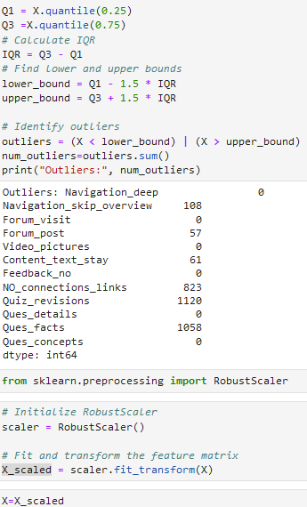

Visualizing outliers in the feature space for a multi-label classification dataset involves examining the distribution of feature values and identifying data points that deviate significantly from the majority of the data. Here's how we can visualize outliers in the feature space for a multi-label classification dataset:

* **Identify Outliers**: Use appropriate statistical methods or algorithms to detect outliers in the feature space. Common techniques include z-score, interquartile range (IQR), or distance-based methods like k-nearest neighbors (KNN) or isolation forest.
* **Visualize Feature Distributions**: Plot histograms or density plots for each feature to visualize their distributions. This helps in identifying features with extreme values or unusual patterns.
* **Highlight Outliers**: Overlay the identified outliers on the feature distribution plots to visually highlight them. This allows you to see which features contribute to the outlier status of the data points.
* **Consider Dimensionality Reduction**: If the dataset has high dimensionality, consider reducing the dimensionality using techniques like Principal Component Analysis (PCA) or t-distributed Stochastic Neighbor Embedding (t-SNE) before visualizing the outliers.

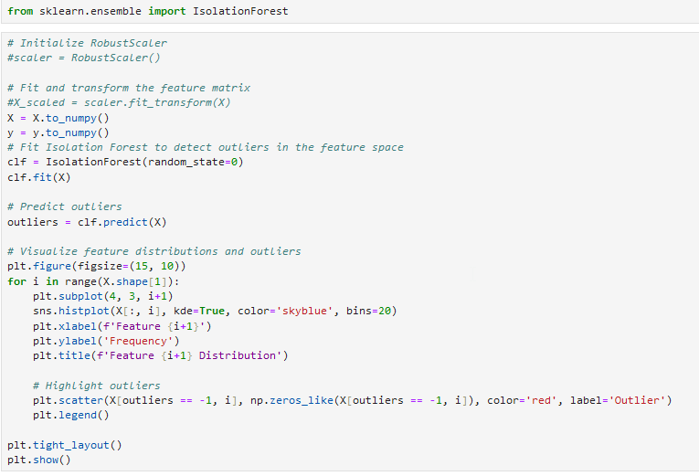

In this code:

* fit an Isolation Forest model to the dataset to detect outliers in the feature space.
* predict outliers using the trained Isolation Forest model.
* visualize the distributions of each feature using histograms and overlay the identified outliers on the plots.

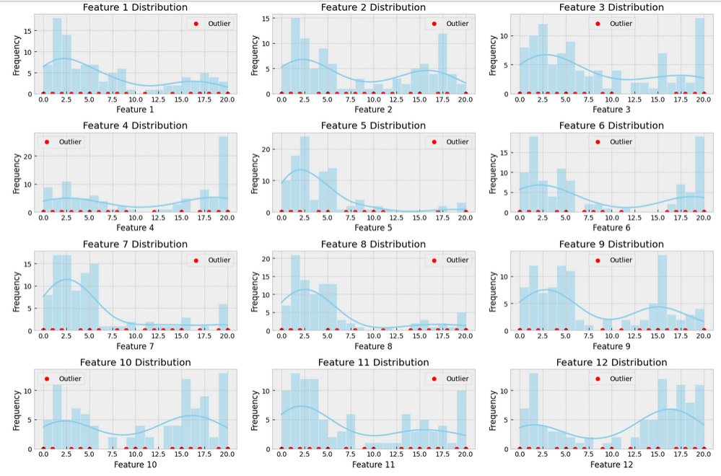

The Isolation Forest model may have detected many outliers for several reasons:

1. **Nature of the data**: The dataset may contain a large number of data points that are significantly different from the majority of the data. This can happen if the dataset is highly heterogeneous or if there are rare instances that deviate from the common patterns.
2. **Dimensionality**: Isolation Forest is known to perform well in high-dimensional spaces. However, in high-dimensional spaces, the concept of distance becomes less meaningful, and the data points tend to be more sparse, leading to a higher likelihood of outliers.
3. **Model parameters**: The performance of Isolation Forest can be sensitive to its hyperparameters, such as the number of trees in the forest (n_estimators) and the maximum depth of each tree (max_depth). Adjusting these parameters might influence the number of outliers detected.
4. **Noise or anomalies**: If the dataset contains noise or anomalies, Isolation Forest may detect them as outliers. These outliers may represent genuine anomalies in the data or errors in the data collection process.
5. **Threshold selection**: Isolation Forest uses a threshold to determine whether a data point is an outlier. The choice of threshold can affect the number of outliers detected. Lowering the threshold may result in more outliers being detected, while raising it may result in fewer outliers.
6. **Scalability**: Isolation Forest is a scalable algorithm that can handle large datasets efficiently. However, its scalability might lead to the detection of more outliers in datasets with a large number of data points.

Overall, the detection of many outliers by the Isolation Forest model could be due to the characteristics of the dataset, the specific parameters chosen for the model, and the nature of the data itself. It's important to carefully examine the outliers detected and consider whether they represent genuine anomalies or errors in the data. Adjusting the model parameters or using alternative outlier detection techniques may help in refining the outlier detection process.

***Robust scaling was applied;***

The RobustScaler is a type of data normalization technique that is particularly useful when dealing with outliers in a dataset. It scales features using statistics that are robust to the presence of outliers, making it less sensitive to extreme values compared to standard normalization techniques like Min-Max scaling or Z-score normalization. Here's how the RobustScaler helps in case of outliers:

* **Medians and quartiles**: Instead of using the mean and standard deviation like standard normalization techniques, the RobustScaler uses the median and interquartile range (IQR) to scale features. The median is less affected by outliers compared to the mean, and the IQR is a robust measure of the spread of the data that is less sensitive to extreme values.
* **Centering and scaling**: The RobustScaler centers the data by subtracting the median and then scales it by dividing by the IQR. This process effectively removes the median and scales the data based on the spread of the middle 50% of the values, making it robust to outliers.
* **Preserves information**: By using robust statistics like the median and IQR, the RobustScaler preserves the relative ordering of values in the dataset while reducing the impact of outliers. This ensures that important information in the data is retained even in the presence of extreme values.
* **Improves model performance**: Scaling features using the RobustScaler can improve the performance of machine learning models, especially those that are sensitive to the scale of features or outliers. By reducing the influence of outliers on feature scaling, the RobustScaler helps models converge faster and produce more accurate predictions.
* **Maintains interpretability**: Unlike techniques that remove outliers or transform data using more complex methods, the RobustScaler preserves the original scale and distribution of features, making it easier to interpret the results of the analysis.

Overall, the RobustScaler is a valuable tool for preprocessing datasets with outliers, as it provides a robust and effective way to scale features while minimizing the impact of extreme values on the normalization process.

**Feature-label space: i**dentifying outliers in feature-label space involves considering both the feature values and their corresponding label combinations. In a multi-label classification context, outliers in feature-label space refer to data points with unusual combinations of feature values across multiple labels. Here are some approaches to identifying outliers in feature-label space:

* **Multivariate Outlier Detection**: Utilize multivariate outlier detection techniques that consider both feature values and label combinations simultaneously. Methods such as Mahalanobis distance, elliptic envelope, or robust covariance estimation can be adapted to handle multi-label data and identify outliers in feature-label space.
* **Dimensionality Reduction**: Apply dimensionality reduction techniques like Principal Component Analysis (PCA) or t-distributed Stochastic Neighbor Embedding (t-SNE) to project the data into a lower-dimensional space while preserving the relationships between features and labels. Outliers in feature-label space may manifest as data points that are distant from the majority of the data points in the reduced-dimensional space.
* **Cluster Analysis**: Perform cluster analysis on the feature-label space to identify groups of data points with similar feature values and label combinations. Outliers can then be identified as data points that do not belong to any of the clusters or are distant from the cluster centroids.
* **Supervised Outlier Detection**: Train a multi-label classification model on the dataset and use it to predict label combinations for each data point. Then, compare the predicted label combinations with the true label combinations to identify discrepancies. Data points with unexpected or incorrect predictions relative to their feature values may be considered outliers in feature-label space.
* **Local Outlier Factor (LOF)**: Calculate the local outlier factor for each data point based on its feature values and label combinations. LOF measures the deviation of a data point's density from the density of its neighbors. Data points with high LOF scores are considered outliers in feature-label space.
* **Visualization Techniques**: Visualize the feature-label space using scatter plots, heatmaps, or parallel coordinate plots. Outliers may appear as data points with extreme feature values relative to their label combinations or as deviations from the typical patterns observed in the data.
* **Domain Knowledge**: Leverage domain knowledge or expert insights to identify combinations of feature values and labels that are unlikely or irrelevant in the context of the problem domain. Outliers may represent rare events, errors in labeling, or instances that do not conform to the expected behavior based on domain expertise.

It's important to note that identifying outliers in feature-label space requires considering the joint distribution of features and labels and may require a combination of statistical, machine learning, and visualization techniques tailored to the specific characteristics of the dataset and the objectives of the analysis.

*Heatmap*

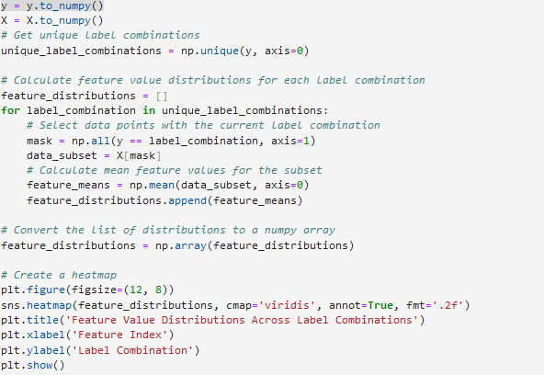

1. Prepare the data: Load or generate your multi-label classification dataset and preprocess it as needed.
2. Group the data by label combinations: Group the dataset based on the unique combinations of labels.
3. Calculate feature value distributions: For each label combination, calculate the distribution of feature values across the dataset.
4. Create a heatmap: Plot the feature value distributions as a heatmap, with features on one axis and label combinations on the other axis.

In the code:

* generate a synthetic multi-label classification dataset using make_multilabel_classification from sklearn.datasets.
* group the dataset by label combinations and calculate the mean feature values for each combination.
* create a heatmap using sns.heatmap() from the Seaborn library to visualize the distribution of feature values across different label combinations.
* the heatmap displays the mean feature values, with features on the x-axis and label combinations on the y-axis.

This heatmap visualization provides insights into how the distribution of feature values varies across different label combinations in the multi-label classification dataset. Adjust the code as needed to fit your specific dataset and visualization preferences.

[0 0 0 0 0 0 0 1]

[0 0 0 0 0 0 1 0]

[0 0 0 0 0 0 1 1]

[0 0 0 0 0 1 0 0]

[0 0 0 0 1 0 0 0]

[0 0 0 0 1 0 0 1]

[0 0 0 1 0 0 0 0]

[0 0 0 1 0 0 0 1]

[0 0 0 1 0 0 1 0]

[0 0 0 1 0 0 1 1]

[0 0 0 1 1 0 0 0]

[0 0 0 1 1 0 1 1]

[0 0 1 0 0 0 0 0]

[0 1 0 0 0 0 0 0]

[0 1 0 0 0 0 0 1]

[0 1 0 0 0 0 1 0]

[0 1 0 0 0 1 0 0]

[0 1 0 0 0 1 1 1]

[0 1 0 0 1 0 0 0]

[0 1 0 0 1 0 0 1]

[0 1 0 1 0 0 0 0]

[0 1 0 1 0 0 1 1]

[0 1 0 1 0 1 0 0]

[0 1 0 1 0 1 0 1]

[0 1 0 1 1 0 0 1]

[0 1 0 1 1 0 1 0]

[1 0 0 0 0 0 0 0]

[1 0 0 0 0 0 0 1]

[1 0 0 0 0 0 1 0]

[1 0 0 0 0 0 1 1]

[1 0 0 0 0 1 0 0]

[1 0 0 0 1 0 0 0]

[1 0 0 0 1 0 1 1]

[1 0 0 1 0 0 0 0]

[1 0 0 1 0 0 1 0]

[1 1 0 0 0 0 0 0]

[1 1 0 0 0 0 0 1]

[1 1 0 0 0 0 1 0]

[1 1 0 0 1 0 0 0]

[1 1 0 1 0 0 0 0]

[1 1 0 1 0 0 0 1]

[1 1 0 1 0 0 1 0]

[1 1 0 1 0 0 1 1]

[1 1 1 1 1 1 0 0]

[[ 4.625 16. 4.375 4.625 4.25 4.25

4.125 4. 3.625 3.25 4.125 15.875 ]

[17.66666667 3.33333333 4. 2.33333333 2.66666667 2.33333333

1.66666667 2.66666667 2.66666667 2.33333333 2.66666667 2. ]

[17. 17. 5. 3. 1. 3.

5. 5. 5. 7. 7. 17. ]

[ 6. 5.25 5. 4.75 4.5 4.5

12.75 12.25 3.75 3.75 4.25 4. ]

[ 4.2 4.2 19. 19.2 2.6 2.8

3.6 3. 4. 5. 3.8 4. ]

[ 3.5 14.5 17.5 17. 3.5 3.5

2. 5. 4.5 2. 4.5 17.5 ]

[ 2. 3. 9.33333333 16. 2. 15.83333333

3.16666667 3. 2.83333333 12. 2.83333333 3.66666667]

[ 4. 15. 12. 19. 4. 17.

4. 6. 7. 18. 2. 17. ]

[18. 4. 3. 19. 4. 20.

4. 1. 1. 20. 1. 1. ]

[15. 16. 12. 15. 3. 18.

3. 5. 5. 10. 2. 18. ]

[ 3. 3. 20. 20. 3. 20.

3. 3. 3. 20. 3. 3. ]

[15. 15. 15. 15. 5. 5.

5. 5. 5. 15. 2. 15. ]

[17.5 17. 17. 17. 17. 16.5

18. 17. 17.5 16.5 16.5 15.5 ]

[ 4.09090909 3.18181818 5.81818182 8.54545455 3.27272727 3.45454545

4.18181818 4.90909091 3.09090909 4.81818182 2.54545455 10.54545455]

[ 3.75 16.5 5. 4.5 6.75 2.25

4.75 2.25 2.25 4. 3.75 17.5 ]

[ 6.5 9. 1. 1. 1. 0.5

1. 1. 1.5 1.5 1.5 15. ]

[ 0. 0. 0. 0. 0. 0.

0. 0. 0. 0. 0. 17. ]

[17. 12. 2. 2. 2. 1.

15. 15. 4. 3. 4. 14. ]

[ 5. 5. 20. 18. 8. 8.

8. 1. 1. 1. 1. 19. ]

[15. 4. 15. 14. 4. 4.

4. 4. 4. 4. 0. 17. ]

[ 4.33333333 3.66666667 11.33333333 19.66666667 4.33333333 18.66666667

2.66666667 2.66666667 2.66666667 16.66666667 2.33333333 15.66666667]

[13. 14. 13. 20. 2. 20.

2. 2. 2. 13. 1. 13. ]

[ 2.5 3. 2. 18.5 2. 19.

13.5 14.5 2. 17.5 2. 13.5 ]

[14. 14. 15. 15. 4. 20.

4. 4. 4. 15. 3. 20. ]

[ 2. 16. 17. 19. 2. 16.

2. 2. 4. 15. 1. 19. ]

[ 5. 20. 14. 18. 5. 17.

5. 5. 5. 13. 2. 15. ]

[ 8. 1. 2. 2. 2. 2.

2. 2. 13. 17. 20. 2. ]

[ 2.5 16.5 2.5 2.5 2.5 2.5

2.5 11. 15. 17. 7.5 19. ]

[18. 1. 1. 1. 1. 1.

1. 1. 14. 20. 15. 1. ]

[17.33333333 17. 1.33333333 3. 2.33333333 3.

2.33333333 2.33333333 14.33333333 13.33333333 16. 16. ]

[ 1. 1. 1. 1. 1. 1.

20. 16. 15. 16. 17. 1. ]

[ 2.66666667 1.66666667 12.66666667 12.33333333 0.33333333 0.33333333

0.33333333 0.33333333 16. 15. 16. 0.66666667]

[12. 18. 13. 13. 2. 4.

2. 2. 12. 13. 13. 13. ]

[ 5. 10. 7. 12. 1. 19.

1. 1. 16. 20. 13. 1. ]

[17. 1. 5. 17. 1. 17.

5. 5. 15. 17. 17. 1. ]

[ 5. 4.75 3.25 3. 3.25 3.25

3.5 3.25 14.75 15.75 14. 15.75 ]

[ 4. 15. 4. 1.5 7.5 5.5

6.5 5. 14.5 16.5 13. 15.5 ]

[20. 2. 5. 5. 7. 2.

2. 2. 15. 16. 17. 15. ]

[ 6. 6. 18. 20. 1. 1.

2. 1. 14. 17. 14. 15. ]

[ 3.25 2. 5.5 16.5 2.5 18.75

3.25 3. 15.75 16.25 18.25 15.5 ]

[ 1. 12. 1. 20. 1. 18.

2. 3. 15. 17. 12. 10. ]

[ 1. 15.5 8. 17. 1. 19.

1.5 1. 15. 15. 20. 19. ]

[16. 10. 1. 1. 1. 1.

1. 1. 14. 10. 7. 1. ]

[ 1. 2. 20. 20. 20. 20.

20. 20. 20. 20. 20. 1. ]]

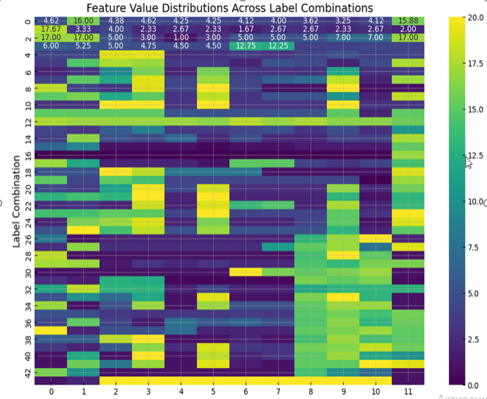

*Scatter plot*

To visualize the feature-label space using scatter plots for a multi-label classification dataset with 8 labels and 12 features, where each sample has 8 labels, you can follow these steps:

* Prepare the data: Load or generate your multi-label classification dataset and preprocess it as needed.
* Group the data by label combinations: Group the dataset based on the unique combinations of labels.
* Reduce dimensionality: Since scatter plots typically visualize data in two dimensions, you'll need to reduce the dimensionality of the feature space. You can use techniques like Principal Component Analysis (PCA) or t-distributed Stochastic Neighbor Embedding (t-SNE) for this purpose.
* Plot the scatter plots: For each label combination, create a scatter plot showing the relationship between the reduced-dimensional feature vectors and the corresponding labels.

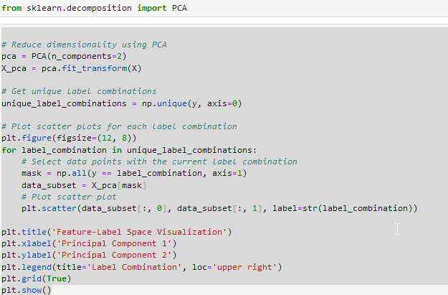

In the code:

* generate a synthetic multi-label classification dataset using make_multilabel_classification from sklearn.datasets.
* reduce the dimensionality of the feature space to two dimensions using PCA.
* plot scatter plots for each unique label combination, where each data point represents a sample in the reduced-dimensional feature space.
* The scatter plots show the relationship between the reduced-dimensional feature vectors and the corresponding label combinations.

This visualization provides insights into the relationship between the feature values and label combinations in the multi-label classification dataset. Adjust the code as needed to fit your specific dataset and visualization preferences.

When applying Principal Component Analysis (PCA) during the visualization of the feature-label space using scatter plots for a multi-label classification dataset with 8 labels and 12 features, PCA is used to reduce the dimensionality of the feature space. Principal components (PCs) are new variables that are constructed as linear combinations of the original features. These new variables are ordered in such a way that the first principal component explains the maximum amount of variance in the dataset, the second principal component explains the second maximum amount of variance, and so on.

In the context of the scatter plots:

* Each principal component represents a new axis in the reduced-dimensional space.
* The first principal component (PC1) captures the direction of maximum variance in the data.
* The second principal component (PC2) captures the direction of maximum variance orthogonal to PC1.
* Each data point in the scatter plot is projected onto these principal components, allowing visualization of the relationships between the samples in the reduced-dimensional space.

In summary, principal components represent the axes of maximum variance in the dataset, and PCA helps to project the original high-dimensional feature space onto a lower-dimensional space while preserving as much variance as possible. This facilitates visualization and interpretation of the relationships between features and label combinations in the scatter plots.

The orthogonality of a second principal component (PC2) in the context of Principal Component Analysis (PCA) refers to its perpendicularity or independence with respect to the first principal component (PC1). In other words, PC2 is orthogonal to PC1, meaning that the direction captured by PC2 is perpendicular to the direction captured by PC1 in the original feature space.

The orthogonality property of principal components is a fundamental characteristic of PCA. When performing PCA, the goal is to find new axes (principal components) along which the data varies the most, and these axes are required to be orthogonal to each other. This orthogonality ensures that each principal component captures a unique and independent direction of variance in the dataset, allowing for efficient dimensionality reduction while retaining as much information as possible.

In practical terms, the orthogonality of PC2 to PC1 means that PC2 captures variance in the data that is not captured by PC1. This property enables PCA to identify and retain distinct patterns or structures in the dataset, making it a powerful technique for dimensionality reduction, data visualization, and feature extraction.

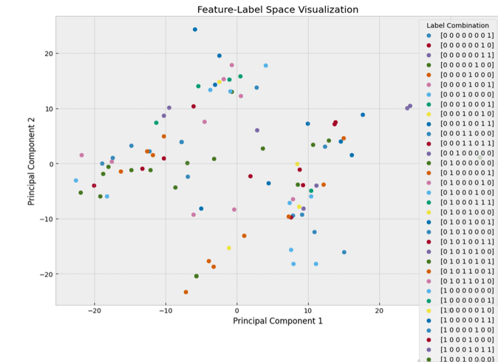

Dealing with outliers in the feature-label space in a multi-label classification dataset involves careful consideration of how outliers impact the modeling process and the desired outcomes. Here are some approaches to consider:

* **Remove outliers**: If outliers are due to errors or anomalies in the data and are expected to negatively impact model performance, consider removing them from the dataset. However, be cautious when removing data points, as outliers may also represent important or rare instances that should not be discarded without careful consideration.
* **Adjust outlier detection**: Utilize outlier detection techniques specific to multi-label datasets to identify and handle outliers in the feature-label space. These techniques may involve considering the distribution of labels across samples and identifying label combinations that deviate significantly from the majority.
* **Robust modeling techniques**: Choose modeling techniques that are robust to outliers and can handle noise in the data effectively. Ensemble methods like Random Forests or Gradient Boosting Machines are generally robust to outliers and can provide stable predictions even in the presence of noise.
* **Feature engineering**: Engineer features to mitigate the impact of outliers or encode information about outlier status directly into the feature space. For example, you could create binary features indicating whether a sample contains outliers in specific features or label combinations.
* **Normalization or scaling**: Apply normalization or scaling techniques to the feature space to reduce the impact of outliers on model training. Robust scaling methods like the RobustScaler, which are less sensitive to outliers, can be particularly useful in this context.
* **Data augmentation**: Augment the dataset by generating synthetic samples that are similar to existing samples but do not contain outliers. This can help balance the dataset and reduce the influence of outliers during model training.
* **Model evaluation**: Evaluate model performance using robust metrics that are less sensitive to outliers, such as F1-score, precision, or recall. Additionally, consider cross-validation techniques to assess model generalization and stability in the presence of outliers.
* **Domain knowledge**: Leverage domain knowledge to interpret and handle outliers appropriately. Understanding the context of the data and the potential sources of outliers can guide decision-making in outlier detection and handling processes.

It's essential to carefully evaluate the implications of each approach and choose the most suitable strategy based on the characteristics of the dataset, the goals of the analysis, and domain expertise. Additionally, iterative experimentation and validation can help refine outlier detection and handling techniques to improve model performance and robustness.

**Label space:** in a multi-label classification context, outliers in label space refer to label combinations that are unusual or unexpected relative to the distribution of labels in the dataset. Here are a few approaches to identifying outliers in label space:

* **Frequency Analysis**: Calculate the frequency of each label combination in the dataset. Label combinations that occur very infrequently or have significantly lower frequencies compared to others may be considered outliers in label space. You can visualize the distribution of label frequencies using histograms or bar plots and identify label combinations with low frequencies.
* **Statistical Thresholds**: Define statistical thresholds based on measures such as mean, median, standard deviation, or quartiles of label frequencies. Label combinations that fall below or above these thresholds may be considered outliers. For example, you could consider label combinations with frequencies below the first quartile minus a certain multiplier of the interquartile range (IQR) as outliers.
* **Clustering Analysis**: Apply clustering algorithms to the label space to group similar label combinations. Outliers can then be identified as label combinations that do not belong to any of the clusters or are distant from the cluster centroids. Clustering methods like K-means or DBSCAN can be useful for this purpose.
* **Association Rule Mining**: Use association rule mining techniques to discover frequent itemsets or co-occurring label combinations in the dataset. Outliers can be identified as rare or unexpected combinations of labels that deviate from the common patterns discovered by association rule mining algorithms.
* **Domain Knowledge**: Leverage domain knowledge or expert insights to identify label combinations that are unlikely or irrelevant in the context of the problem domain. Outliers may represent rare events, errors in labelling, or instances that do not conform to the expected behavior based on domain expertise.
* **Anomaly Detection**: Apply anomaly detection techniques specifically designed for identifying outliers in categorical or binary data. These methods include isolation forests, one-class SVM, or autoencoders trained on label data.

It's important to note that the definition of outliers in label space may vary depending on the specific characteristics of the dataset and the objectives of the analysis. Additionally, a combination of multiple approaches and domain expertise is often necessary to effectively identify outliers in label space.

**Visualizing** outliers in the label space for a multi-label classification dataset involves identifying label combinations that occur infrequently or deviate significantly from the typical distribution of labels. Since each sample can have multiple labels, outliers in the label space may represent rare or unexpected combinations of labels. Here's how you can visualize outliers in the label space for a multi-label classification dataset with 8 labels and 12 features, where each sample has 8 labels:

* **Calculate Label Frequencies**: Count the frequency of occurrence for each unique label combination in the dataset.
* **Identify Outliers**: Define a criterion for identifying outliers based on label frequencies. For example, you can consider label combinations that occur below a certain threshold or have frequencies that fall outside a specified range as outliers.
* **Visualize Outliers**: Plot the label frequencies and highlight outliers using a different colour or marker. Additionally, you can annotate the plot to indicate which label combinations are considered outliers.

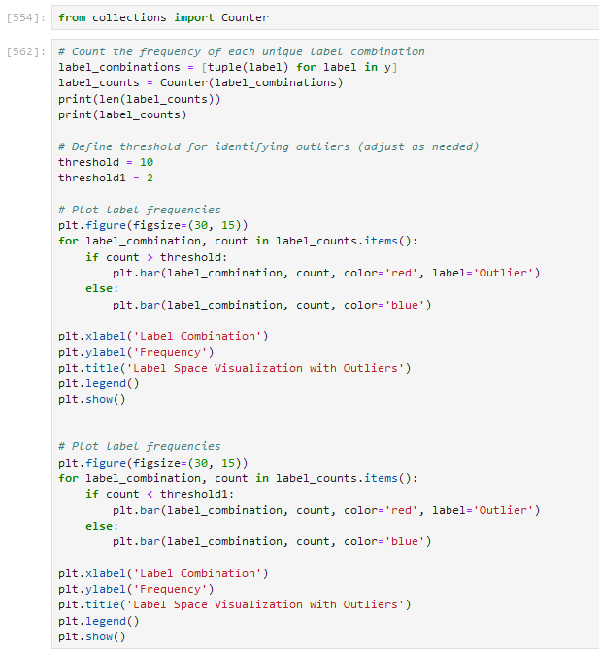

In this code:

* generate a synthetic multi-label classification dataset with random labels for demonstration purposes. Replace labels with your actual dataset.
* count the frequency of occurrence for each unique label combination using the Counter class from Python's collections module.
* define a threshold (threshold) for identifying outliers based on label frequencies. Label combinations with frequencies below this threshold are considered outliers.
* plot the label frequencies using a bar plot and highlight outliers in red, while non-outliers are plotted in blue.

Only one unique label combination:

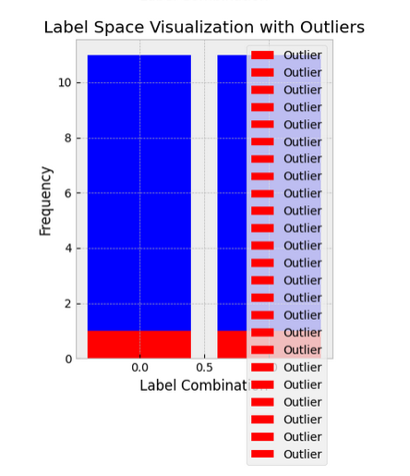

More than 10 samples with the same label combination: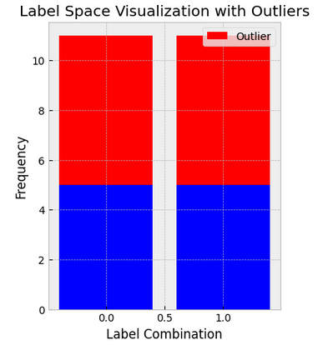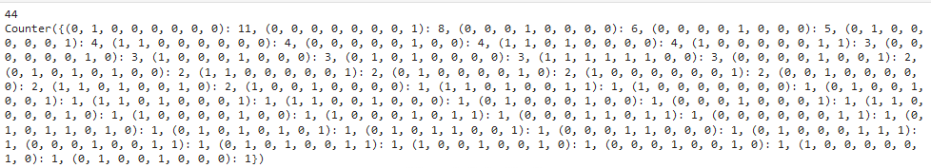

Dealing with a dataset that has many outliers in the label space in the context of multi-label classification depends on the specific characteristics of the dataset and the goals of the analysis. Here are some approaches to consider:

* **Remove outliers**: If the outliers in the label space are due to errors or anomalies in the data, you may consider removing them from the dataset. However, be cautious when removing data points, as outliers may also represent important or rare instances that should not be discarded without careful consideration.
* **Aggregate labels**: If the dataset contains a large number of unique label combinations, consider aggregating labels based on certain criteria. For example, you could group similar label combinations or combine labels with low frequencies into a single category.
* **Thresholding**: Define a threshold for outlier detection based on label frequencies. Label combinations that occur below a certain threshold may be considered outliers and can be treated differently in the analysis.
* **Feature engineering**: Extract features from the label space or incorporate domain knowledge to create new features that capture patterns or relationships in the label combinations. These features can help improve the performance of the multi-label classification model and mitigate the impact of outliers.
* **Model selection**: Choose appropriate machine learning models that are robust to outliers in the label space. Some models, such as decision trees or ensemble methods like random forests, are less sensitive to outliers compared to others.
* **Ensemble methods**: Use ensemble methods that combine multiple models to make predictions. Ensemble methods can help reduce the impact of outliers by averaging the predictions of multiple models or using techniques like bagging and boosting.
* **Data augmentation**: Augment the dataset by generating synthetic label combinations or augmenting existing samples with noise or perturbations. Data augmentation techniques can help increase the diversity of the dataset and improve the robustness of the multi-label classification model.
* **Outlier detection algorithms**: Apply outlier detection algorithms specifically designed for multi-label data to identify and handle outliers in the label space. These algorithms can help identify anomalous label combinations and facilitate targeted interventions.
* **Cross-validation**: Use cross-validation techniques to evaluate the performance of the multi-label classification model and assess its robustness to outliers. Cross-validation can help identify models that generalize well to unseen data, even in the presence of outliers.

It's important to carefully evaluate the implications of each approach and choose the most suitable strategy based on the characteristics of the dataset and the objectives of the analysis. Additionally, domain expertise and knowledge of the specific problem domain can inform decision-making when dealing with outliers in the label space.

***Balancing of a data set was performed.***